Experiment-1

Aim:- Introduction to Prolog.

Application:-

Prolog is a declarative programming language widely used for tasks that involve symbolic reasoning, logic-based problem-solving, and artificial intelligence (AI). Its unique strengths lie in its ability to handle complex relationships, backtracking, and pattern matching efficiently. Below are some key applications of Prolog:

- Artificial Intelligence (AI) and Expert Systems
- Natural Language Processing (NLP)
- Knowledge Representation and Reasoning
- Solving Puzzles and Games
- Constraint Logic Programming (CLP)

Syntax:-

Prolog is a declarative programming language that uses facts, rules, and queries to represent and solve problems. Below is a breakdown of the key components of Prolog syntax:

Facts
Facts represent basic information or knowledge that is always true. A fact consists of a head (predicate) followed by an argument.
Eg: likes(john, pizza).

Rules
Rules are used to define relationships between facts. A rule has a head (what we want to prove or deduce) and a body (conditions that must be true for the head to be true). Rules are written with a :- symbol, where the body precedes the head.
Eg: grandfather(X, Y) :- father(X, Z), father(Z, Y).

Queries
Queries are used to ask Prolog questions about the facts and rules that have been defined. A query is similar to a fact, but it is not terminated with a period when being asked. When asking a query, Prolog will attempt to match it with facts and rules.
Eg: ?- likes(john, pizza).
Variables
Variables in Prolog are written in uppercase letters or with an underscore _. Variables can stand for any term and are used to match facts or rules.
Eg: likes(john, X).

Atoms
Atoms are constant values in Prolog. These can be:
- Simple atoms: Lowercase letters, or atoms enclosed in single quotes if they contain spaces or special characters.
- Examples:
  - john
  - 'big apple'
  - house

Compound Terms
A compound term consists of a functor and its arguments. The functor is similar to a function name, and the arguments are the terms associated with it. Arguments can be atoms, numbers, variables, or other compound terms.
Eg: parent(john, mary).
book('Prolog for Beginners', john).
Software:-
SWI-Prolog is a widely-used open-source implementation of the Prolog programming language. It provides a comprehensive environment for developing logic-based applications. SWI-Prolog is known for its powerful and efficient execution engine, rich set of libraries, and active community.
Installation of SWI-Prolog:-
- Go to the official SWI-Prolog download page:
https://www.swi-prolog.org/download/stable
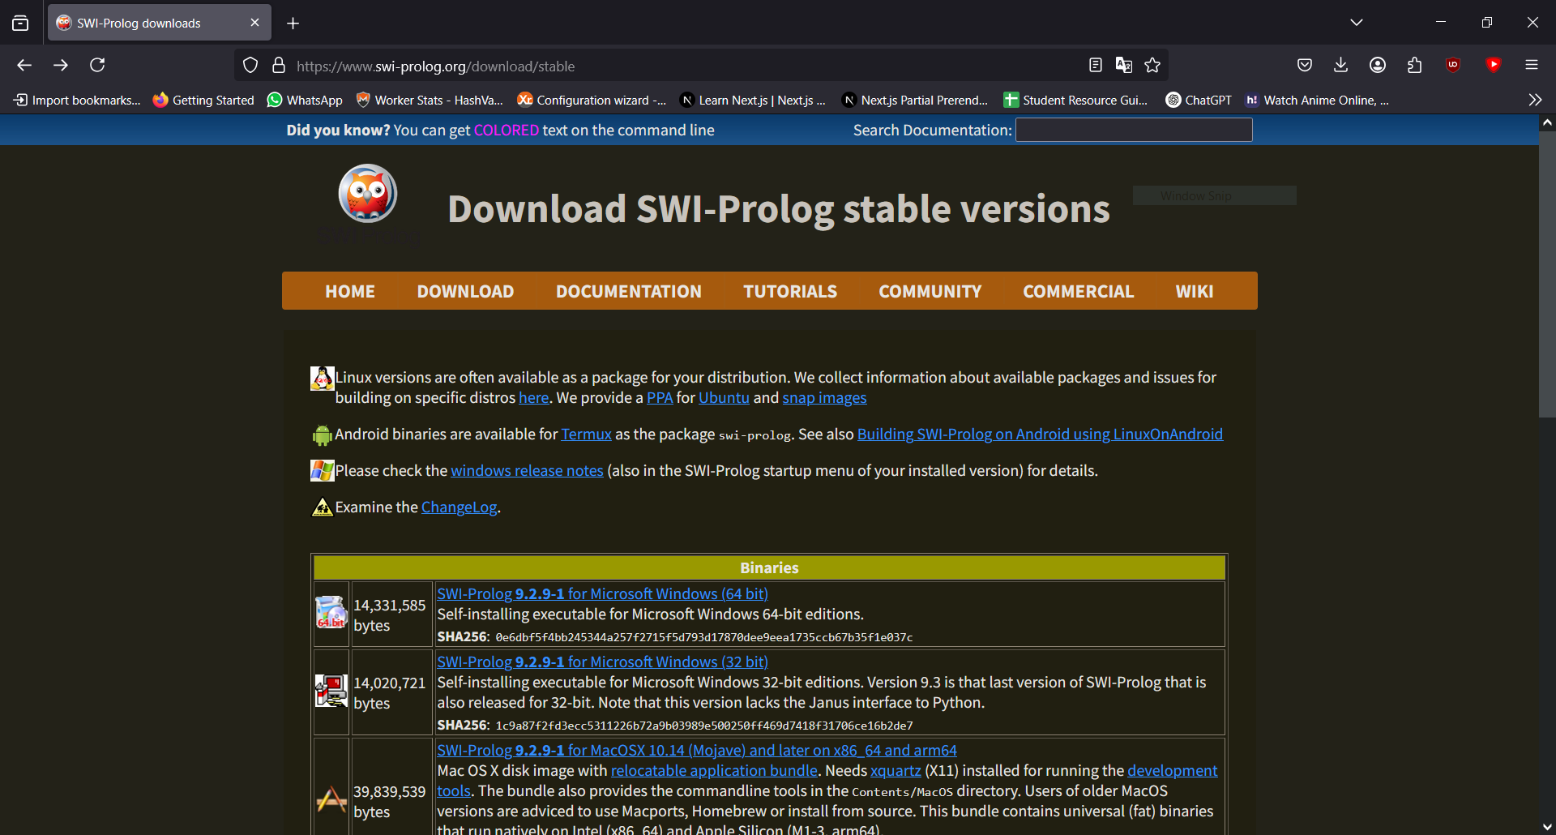
- Download the installer for Windows.
- Run the installer and follow the installation instructions.
- Click Next.
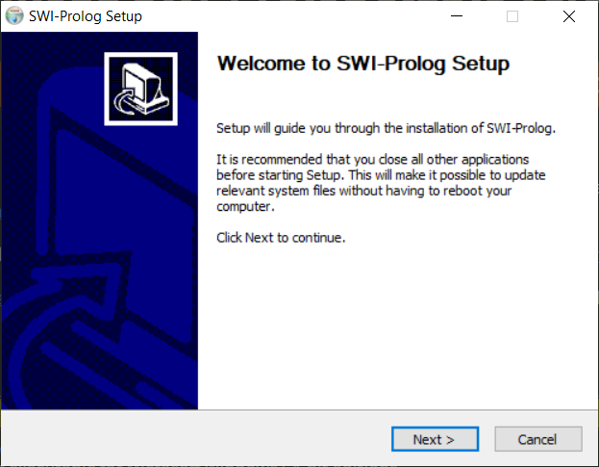
- Click On ‘I Agree’.
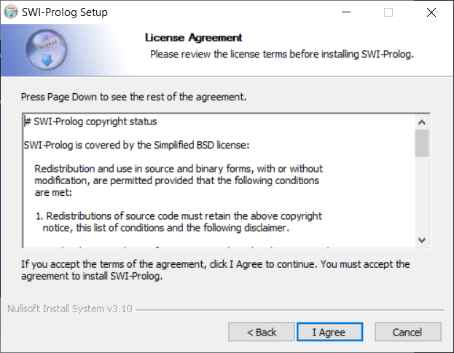
- Select 2nd Radio button and click next.
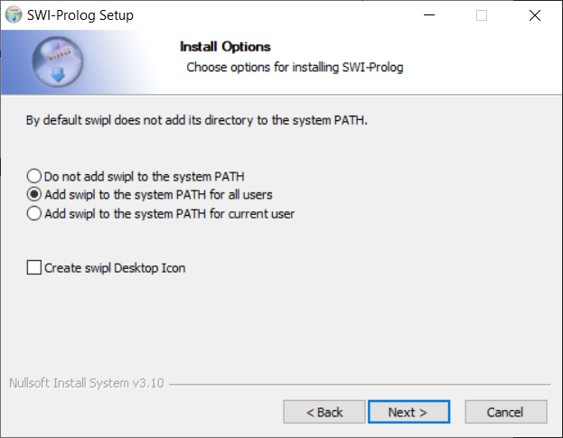
- Click Next.
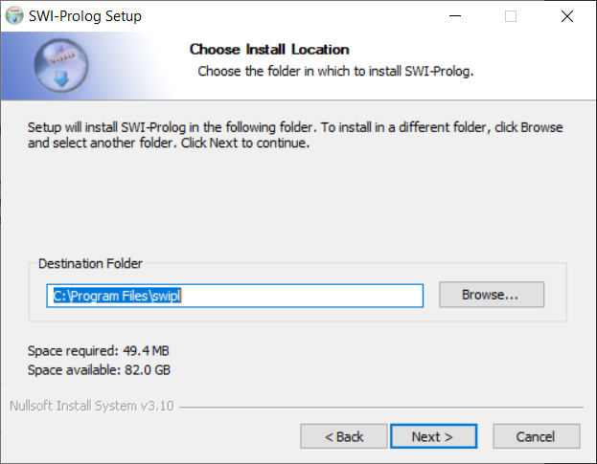
- Click Next.
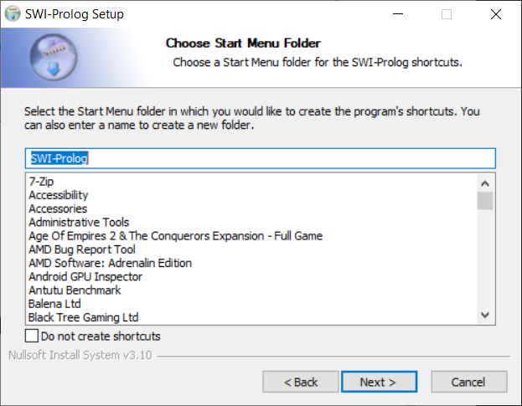
- Click Install.
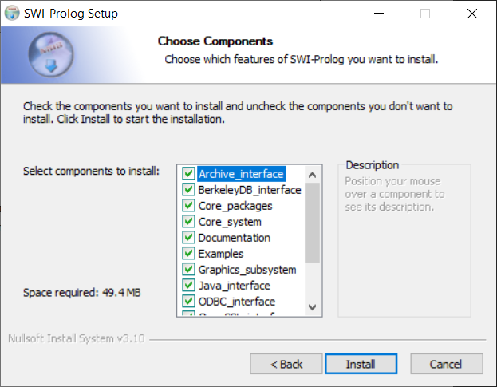

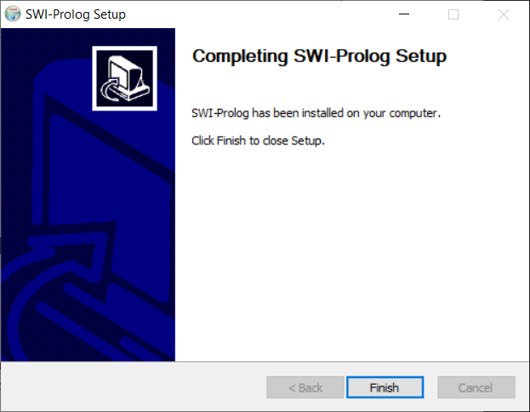

- Once installed, you can run SWI-Prolog by clicking the SWI-Prolog icon or using the command prompt by typing swipl.
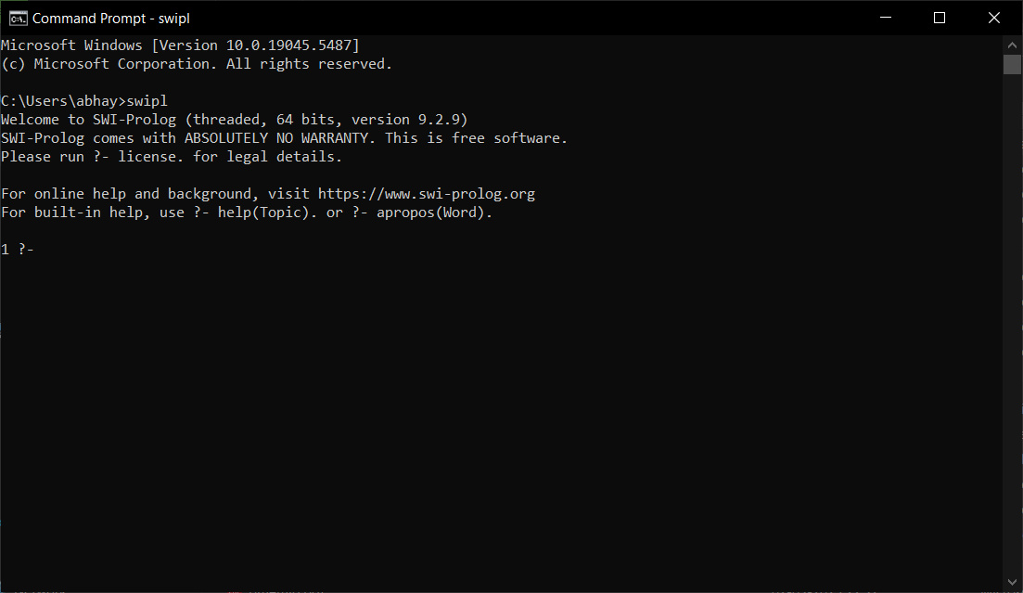

Experiment – 2
Aim:- Write a program to implement the input-output or predicate of PROLOG.
a. Calculate the square of a number.
b. Calculate the area of a circle, square, and rectangle.
c. Calculate the simple interest.
Code:-
% Calculate the square of a number
square(Number, Result) :-
Result is Number * Number.

% Calculate the area of a circle
area_circle(Radius, Area) :-
Area is 3.14159 * Radius * Radius.

% Calculate the area of a square
area_square(Side, Area) :-
Area is Side * Side.

% Calculate the area of a rectangle
area_rectangle(Length, Width, Area) :-
Area is Length * Width.

% Calculate the simple interest
simple_interest(Principal, Rate, Time, Interest) :-
Interest is (Principal * Rate * Time) / 100.

Output:-
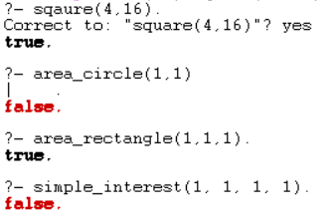
Experiment – 3
Aim:- Write a program to implement local variables and conditional statements in
PROLOG.
a. To check whether a number is even or odd.
b. To find the maximum of two numbers.
c. To find grades of students based on marks achieved:
● Marks ≥ 90 (A Grade).
● 75 ≤ Marks ≤ 90 (B Grade).
● 50 ≤ Marks ≤ 75 (C Grade).
● Marks < 50 (Fail).
Code:-
% Check whether a number is even or odd
even(Number) :-
Number mod 2 =:= 0.

odd(Number) :-
Number mod 2 =\= 0.

% Find the maximum of two numbers
max(X, Y, X) :-
X >= Y.
max(X, Y, Y) :-
Y > X.

% Find grades of students based on marks achieved
grade(Marks, 'A Grade') :-
Marks >= 90.
grade(Marks, 'B Grade') :-
Marks >= 75,
Marks < 90.
grade(Marks, 'C Grade') :-
Marks >= 50,
Marks < 75.
grade(Marks, 'Fail') :-
Marks < 50.

Output:-
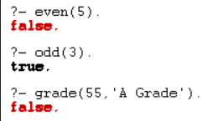
Experiment – 4
Aim:- Write simple facts for the statements using PROLOG
a. Ram likes mango.
b. Seema is a girl.
c. Bill likes Cindy.
d. Rose is red.
e. John owns gold.
Code:-
% Facts
likes(ram, mango).
girl(seema).
likes(bill, cindy).
color(rose, red).
owns(john, gold).

Output:-
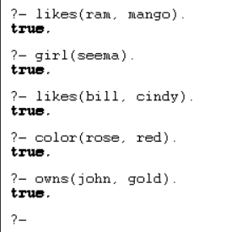
Experiment – 5
Aim:- Write predicates: one converts centigrade temperatures to Fahrenheit, and
the other checks if a temperature is below freezing using PROLOG.
Code:-
%Write predicates, one converts centigrade temperatures to Fahrenheit, the other checksif a temperature is below freezing using PROLOG.
% Convert Centigrade to Fahrenheit
c_to_f(C, F) :-
F is (C * 9 / 5) + 32.

% Check if temperature is below freezing
below_freezing(C) :-
C < 0.

Output:-

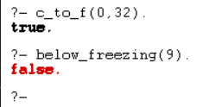
Experiment – 6
Aim:- Write a program to implement Depth First Search Traversal.
Code:-
edge(a, b).
edge(b, c).
edge(c, d).
edge(d, a).
edge(b, e).

show_edges :-
write('Edges of the graph:'), nl,
edge(X, Y),
write(X), write(' -> '), write(Y), nl,
fail.
show_edges.

show_neighbors(Node) :-
write('Neighbors of '), write(Node), write(':'), nl,
edge(Node, Neighbor),
write(Neighbor), nl,
fail.
show_neighbors(_).

show_graph :-
show_edges, nl,
show_neighbors(a),
show_neighbors(b),
show_neighbors(c),
show_neighbors(d).

dfs(Node, Visited) :-
write('Visiting node: '), write(Node), nl,
edge(Node, Neighbor),
not(member(Neighbor, Visited)),
dfs(Neighbor, [Node | Visited]).
dfs(_, _).

start_dfs(Node) :-
write('Start DFS from node: '), write(Node), nl,
dfs(Node, []).

Output:-
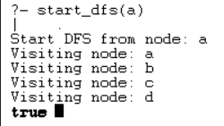

Experiment – 7
Aim:- Write a program to implement the water jug problem using Prolog.
Code:-
%input: move(0,0,[(0,0)]).
member(X,[X|_]).
member(X,[Y|Z]):-member(X,Z).

move(X,Y,_):-X=:=2,Y=:=0,write('done'),!.
move(X,Y,Z):-X<4,\+member((4,Y),Z),write("fill 4 jug"),nl,move(4,Y,[(4,Y)|Z]).
move(X,Y,Z):-Y<3,\+member((X,3),Z),write("fill 3 jug"),nl,move(X,3,[(X,3)|z]).
move(X,Y,Z):-X>0,\+member((0,Y),Z),write("pour 4 jug"),nl,move(0,Y,[(0,Y)|Z]).
move(X,Y,Z):-Y>0,\+member((X,0),Z),write("pour 3 jug"),nl,move(X,0,[(X,0)|Z]).
move(X,Y,Z):-P is X+Y,P>=4,Y>0,K is 4-X,M is Y-K,\+member((4,M),Z),write("pour from 3jug to 4jug"),nl,move(4,M,[(4,M)|Z]).
move(X,Y,Z):-P is X+Y,P>=3,X>0,K is 3-Y,M is X-K,\+member((M,3),Z),write("pour from 4jug to 3jug"),nl,move(M,3,[(M,3)|Z]).
move(X,Y,Z):-K is X+Y,K<4,Y>0,\+member((K,0),Z),write("pour from 3jug to 4jug"),nl,move(K,0,[(K,0)|Z]).
move(X,Y,Z):-K is X+Y,K<3,X>0,\+member((0,K),Z),write("pour from 4jug to 3jug"),nl,move(0,K,[(0,K)|Z]).

Output:-
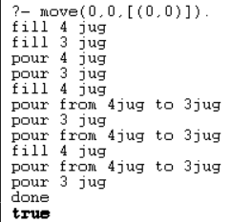
Experiment – 8
Aim:- Write a program to solve 8 puzzle problem using Prolog.
Code:-
% Simple Prolog Planner for the 8 Puzzle Problem

/* This predicate initialises the problem states. The first argument of solve is the initial state, the 2nd the goal state, and the third the plan that will be produced.*/

test(Plan):-
write('Initial state:'),nl,
Init= [at(tile4,1), at(tile3,2), at(tile8,3), at(empty,4), at(tile2,5), at(tile6,6), at(tile5,7), at(tile1,8), at(tile7,9)],
write_sol(Init),
Goal= [at(tile1,1), at(tile2,2), at(tile3,3), at(tile4,4), at(empty,5), at(tile5,6), at(tile6,7), at(tile7,8), at(tile8,9)],
nl,write('Goal state:'),nl,
write(Goal),nl,nl,
solve(Init,Goal,Plan).

solve(State, Goal, Plan):-
solve(State, Goal, [], Plan).

% Determines whether Current and Destination tiles are a valid move.
is_movable(X1,Y1) :- (1 is X1 - Y1) ; (-1 is X1 - Y1) ; (3 is X1 - Y1) ; (-3 is X1 - Y1).

/* This predicate produces the plan. Once the Goal list is a subset of the current State the plan is complete and it is written to the screen using write_sol */

solve(State, Goal, Plan, Plan):-
is_subset(Goal, State), nl,
write_sol(Plan).

solve(State, Goal, Sofar, Plan):-
act(Action, Preconditions, Delete, Add),
is_subset(Preconditions, State),
\+ member(Action, Sofar),
delete_list(Delete, State, Remainder),
append(Add, Remainder, NewState),
solve(NewState, Goal, [Action|Sofar], Plan).

/* The problem has three operators.
1st arg = name
2nd arg = preconditions
3rd arg = delete list
4th arg = add list. */

% Tile can move to new position only if the destination tile is empty & Manhattan distance = 1
act(move(X,Y,Z),
[at(X,Y), at(empty,Z), is_movable(Y,Z)],
[at(X,Y), at(empty,Z)],
[at(X,Z), at(empty,Y)]).

% Utility predicates.

% Check is first list is a subset of the second

is_subset([H|T], Set):-
member(H, Set),
is_subset(T, Set).
is_subset([], _).

% Remove all elements of 1st list from second to create third.

delete_list([H|T], Curstate, Newstate):-
remove(H, Curstate, Remainder),
delete_list(T, Remainder, Newstate).
delete_list([], Curstate, Curstate).

remove(X, [X|T], T).
remove(X, [H|T], [H|R]):-
remove(X, T, R).

write_sol([]).
write_sol([H|T]):-
write_sol(T),
write(H), nl.

append([H|T], L1, [H|L2]):-
append(T, L1, L2).
append([], L, L).

member(X, [X|_]).
member(X, [_|T]):-
member(X, T).

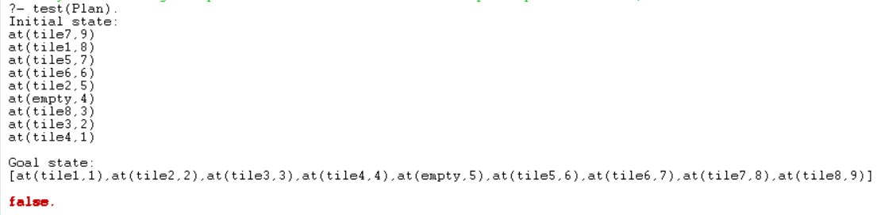
Output:-
Experiment – 9
Aim:- Write a program to implement a Tic-Tac-Toe game using Prolog.
Code:-
win(b, p) :- rowwin(b, p).
win(b, p) :- colwin(b, p).
win(b, p) :- diagwin(b, p).

rowwin(b, p) :- b = [p,p,p,_,_,_,_,_,_].
rowwin(b, p) :- b = [_,_,_,p,p,p,_,_,_].
rowwin(b, p) :- b = [_,_,_,_,_,_,p,p,p].

colwin(b, p) :- b = [p,_,_,p,_,_,p,_,_].
colwin(b, p) :- b = [_,p,_,_,p,_,_,p,_].
colwin(b, p) :- b = [_,_,p,_,_,p,_,_,p].

diagwin(b, p) :- b = [p,_,_,_,p,_,_,_,p].
diagwin(b, p) :- b = [_,_,p,_,p,_,p,_,_].

other(x,o).
other(o,x).

game(b, p) :- win(b, p), !, write([p, p, wins]).
game(b, p) :-
other(p,Otherp),
move(b,p,Newb),
!,
display(Newb),
game(Newb,Otherp).

move([b,B,C,D,E,F,G,H,I], p, [p,B,C,D,E,F,G,H,I]).
move([A,b,C,D,E,F,G,H,I], p, [A,p,C,D,E,F,G,H,I]).
move([A,B,b,D,E,F,G,H,I], p, [A,B,p,D,E,F,G,H,I]).
move([A,B,C,b,E,F,G,H,I], p, [A,B,C,p,E,F,G,H,I]).
move([A,B,C,D,b,F,G,H,I], p, [A,B,C,D,p,F,G,H,I]).
move([A,B,C,D,E,b,G,H,I], p, [A,B,C,D,E,p,G,H,I]).
move([A,B,C,D,E,F,b,H,I], p, [A,B,C,D,E,F,p,H,I]).
move([A,B,C,D,E,F,G,b,I], p, [A,B,C,D,E,F,G,p,I]).
move([A,B,C,D,E,F,G,H,b], p, [A,B,C,D,E,F,G,H,p]).

display([A,B,C,D,E,F,G,H,I]) :- write([A,B,C]),nl,write([D,E,F]),nl,
write([G,H,I]),nl,nl.

selfgame :- game([b,b,b,b,b,b,b,b,b],x).

x_can_win_in_one(b) :- move(b, x, Newb), win(Newb, x).

orespond(b,Newb) :-
move(b, o, Newb),
win(Newb, o),
!.
orespond(b,Newb) :-
move(b, o, Newb),
not(x_can_win_in_one(Newb)).
orespond(b,Newb) :-
move(b, o, Newb).
orespond(b,Newb) :-
not(member(b,b)),
!,
write('Cats game!'), nl,
Newb = b.

xmove([b,B,C,D,E,F,G,H,I], 1, [x,B,C,D,E,F,G,H,I]).
xmove([A,b,C,D,E,F,G,H,I], 2, [A,x,C,D,E,F,G,H,I]).
xmove([A,B,b,D,E,F,G,H,I], 3, [A,B,x,D,E,F,G,H,I]).
xmove([A,B,C,b,E,F,G,H,I], 4, [A,B,C,x,E,F,G,H,I]).
xmove([A,B,C,D,b,F,G,H,I], 5, [A,B,C,D,x,F,G,H,I]).
xmove([A,B,C,D,E,b,G,H,I], 6, [A,B,C,D,E,x,G,H,I]).
xmove([A,B,C,D,E,F,b,H,I], 7, [A,B,C,D,E,F,x,H,I]).
xmove([A,B,C,D,E,F,G,b,I], 8, [A,B,C,D,E,F,G,x,I]).
xmove([A,B,C,D,E,F,G,H,b], 9, [A,B,C,D,E,F,G,H,x]).
xmove(b, _, b) :- write('Illegal move.'), nl.

playo :- explain, playfrom([b,b,b,b,b,b,b,b,b]).

explain :-
write('You play X by entering integer positions followed by a period.'),
nl,
display([1,2,3,4,5,6,7,8,9]).

playfrom(b) :- win(b, x), write('You win!').
playfrom(b) :- win(b, o), write('I win!').
playfrom(b) :- read(N),
xmove(b, N, Newb),
display(Newb),
orespond(Newb, Newnewb),
display(Newnewb),
playfrom(Newnewb).

Output:-
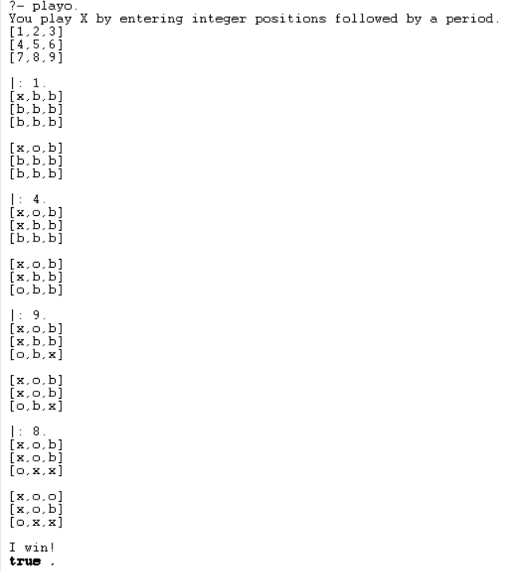

Experiment – 10
Aim:- Write a program to implement the Hangman game using Python.
Code:-
import random as r
d=r.choice

def h():
w=d(["python","java","kotlin","js","hangman","dev","code","YPS"]);g=set();a=6
print("Hangman!")
while a:
print(" ".join(l if l in g else "_" for l in w))
i=input("Guess:").lower()
if len(i)!=1 or not i.isalpha()or i in g:continue
g.add(i);a-=(i not in w)
if all(l in g for l in w):print("Win!",w);return
print("Lost!",w)
h()

output:
Hangman!
_ _ _ _ _ _
Guess:k
_ _ _ _ _ _
Guess:h
_ _ _ h _ _
Guess:p
p _ _ h _ _
Guess:y
p y _ h _ _
Guess:t
p y t h _ _
Guess:o
p y t h o _
Guess:n
Win! python
Experiment – 11
Aim:- Write a program to implement stemming for a given sentence using NLTK.
Code:-
import nltk
from nltk.stem import PorterStemmer as P
from nltk.tokenize import word_tokenize as w
nltk.download('punkt')
nltk.download('punkt_tab')
s=input("Enter: ")
print(" ".join(P().stem(i) for i in w(s)))

output:
[nltk_data] Downloading package punkt to /home/abhay/nltk_data...
[nltk_data] Package punkt is already up-to-date!
[nltk_data] Downloading package punkt_tab to /home/abhay/nltk_data...
[nltk_data] Package punkt_tab is already up-to-date!
Enter: running
run
Experiment – 12
Aim:- Write a program to POS (part of speech) tagging for the given sentence
using NLTK.
Code:-
import nltk
from nltk.tokenize import word_tokenize as w
from nltk import pos_tag as p
nltk.download('punkt')
nltk.download('averaged_perceptron_tagger')
print(p(w(input("Enter: "))))

output:
[nltk_data] Downloading package punkt to /home/abhay/nltk_data...
[nltk_data] Package punkt is already up-to-date!
[nltk_data] Downloading package averaged_perceptron_tagger to
[nltk_data] /home/abhay/nltk_data...
[nltk_data] Package averaged_perceptron_tagger is already up-to-
[nltk_data] date!
Enter: I am going to movie.
[('I', 'PRP'), ('am', 'VBP'), ('going', 'VBG'), ('to', 'TO'), ('movie', 'NN'), ('.', '.')]
Experiment – 13
Aim:- Write a program to implement Lemmatization using NLTK.
Code:-
import nltk
from nltk.stem import WordNetLemmatizer as L
from nltk.tokenize import word_tokenize as w
from nltk.corpus import wordnet as wn
nltk.download('punkt')
nltk.download('omw-1.4')
l=L()
def f(wd):return l.lemmatize(wd,pos=wn.VERB)
print(" ".join(f(i) for i in w(input("Enter: "))))

Output:
[nltk_data] Downloading package punkt to /home/abhay/nltk_data...
[nltk_data] Package punkt is already up-to-date!
[nltk_data] Downloading package omw-1.4 to /home/abhay/nltk_data...
[nltk_data] Package omw-1.4 is already up-to-date!
Enter: running
run
Experiment – 14
Aim:- Write a program for Text Classification for the given sentence using
NLTK.
Code:-
import nltk
from nltk.classify import NaiveBayesClassifier
from nltk.tokenize import word_tokenize
nltk.download('punkt')
def fs(sen):
return {word: True for word in word_tokenize(sen)}
td = []
with open("td.txt", "r") as f:
for line in f:
parts = line.strip().rsplit(" ", 1) # Split only at the last space
if len(parts) == 2 and parts[1] in ["positive", "negative"]:
td.append((parts[0], parts[1]))
train_set = [(fs(text), label) for text, label in td]
classifier = NaiveBayesClassifier.train(train_set)

sen = input("Enter a sen: ")
print("Sentiment:", classifier.classify(fs(sen)))
Output:-
[nltk_data] Downloading package punkt to /home/abhay/nltk_data...
[nltk_data] Package punkt is already up-to-date!
Enter a sentence: this movie is so great!!!
Sentiment: positive

